Assignment 1
Algorithmic Fairness Analysis
UCI Adult Income Dataset
Gender and Race Bias Audit

Name: Budike Meeraj Kumar
GH Number: GH1040835
Module: M515A Ethical Issues for AI

Introduction
This report is about the algorithmic fairness using the UCI Adult Income dataset. The primary objective is to develop a binary classifier that forecasts who makes over $50K annually and subsequently create the model to examine discriminatory practices among different demographic groups.
The two characteristics are Sex and Ethnicity (White, Black, Asian-Pacific-Islander, American-Indian-Eskimo, Other).

1. Data Loading
This dataset contains 15 columns with32,561 record.

Column | Type | Description
age | Numeric | Age of the individual
workclass | Categorical | Type of employer
fnlwgt | Numeric | Census sampling weight
education | Categorical | Education level attained
education-num | Numeric | Education level as integer (1-16)
marital-status | Categorical | Marital status
occupation | Categorical | Job type
relationship | Categorical | Family relationship role
race | Categorical (sensitive) | Racial group
sex | Categorical (sensitive) | Gender
capital-gain | Numeric | Capital gains from investments
capital-loss | Numeric | Capital losses from investments
hours-per-week | Numeric | Average working hours per week
native-country | Categorical | Country of origin
salary | Binary (target) | <=50K or >50K annual income

Target Variable Distribution :

The dataset has 32,561 samples split into two salary classes:
- ≤50K: 24,720 samples -75.9%
- >50K: 7,841 samples - 24.1%
The data is imbalanced with 3:1 ratio favouring the lower income class.
Class balance: {<=50K == 0.759, >50K== 0.241}

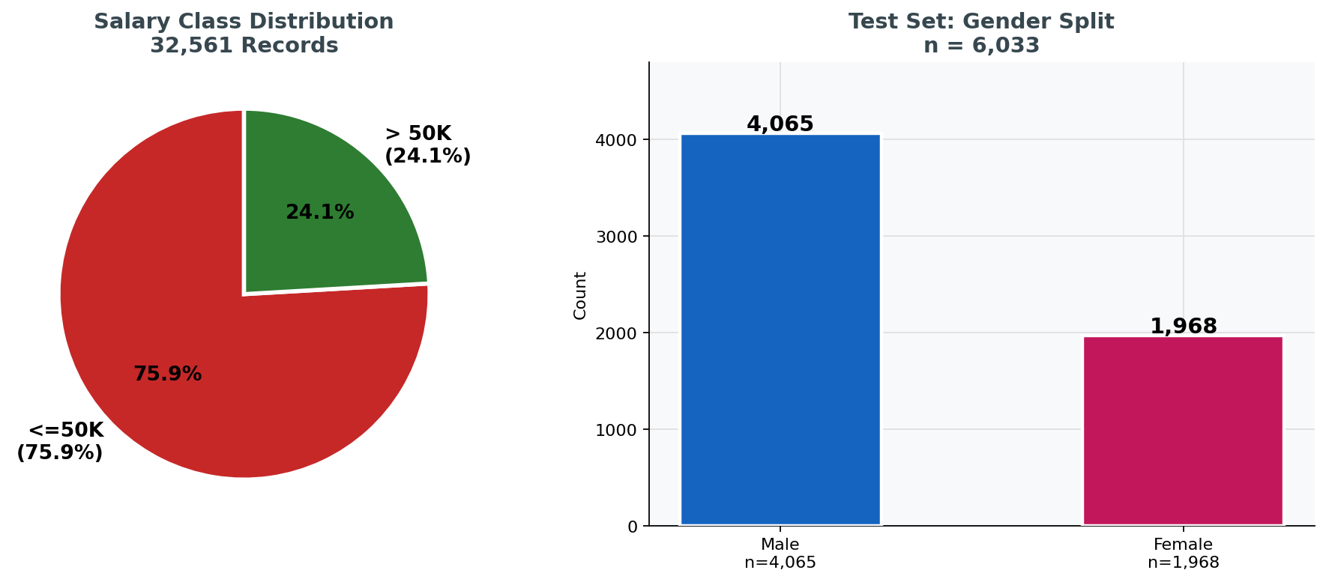
Figure 1: Salary class distribution and test-set gender split

2. Preprocessing

2.1 Missing Values
Whitespace was stripped from all string columns. '?' values were replaced with NaN. Missing value counts found:
workclass 1,836 missing rows
occupation 1,843 missing rows
native-country 583 missing rows
All rows with missing values were dropped.
Rows after dropping missing values: 30,162

2.2 Sensitive Attribute Preservation
Before encoding, the raw sex and race columns were saved separately as sex_col and race_col. These are used to split the test set by demographic group during fairness analysis, and are not used as model features in isolation.
Sex groups : Male, Female
Race groups: White, Black, Asian-Pac-Islander, Amer-Indian-Eskimo, Others

2.3 Encoding and Scaling
All categorical columns were encoded using LabelEncoder (integer codes). StandardScaler was fitted on the training set only and applied to both train and test sets to prevent data leakage.
StandardScaler: z = (x - mu) / sigma
mu = feature mean from TRAINING data only
sigma = feature std from TRAINING data only

2.4 Train / Test Split

The dataset is split into 80/2 ,training 80%(24,129) and test 20%(6,033).

3. Model Training
Logistic Regression is chosen for its simplicity, interpretability and suitability for the classification. No fairness constraints were applied in this stage.
model = LogisticRegression (max iter=1000, random state=42)
model.fit(X_train_scaled, y_train)

4. Overall Model Evaluation:

4.1 Accuracy
Overall Accuracy of the model is 0.8175.

4.2 Classification Report
Class | Precision | Recall | F1-Score | Support
<=50K | 0.84 | 0.94 | 0.89 | 4,531
>50K | 0.71 | 0.45 | 0.55 | 1,502

Accuracy |  |  | 0.82 | 6,033
Macro avg | 0.78 | 0.69 | 0.72 | 6,033
Weighted avg | 0.81 | 0.82 | 0.80 | 6,033

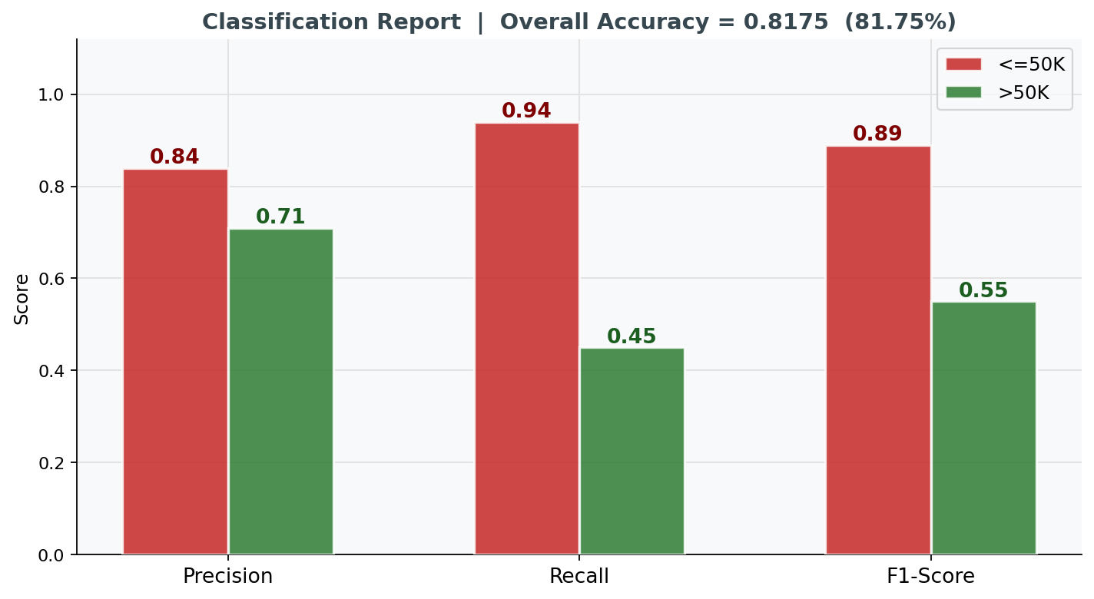
Figure 2: Precision, Recall and F1-Score of the both salary classes

The model performs well on the majority class salary <=50K with F1 score is 0.89 but poorly on the minority class of salary>50K with F1 score 0.55 and Recall as 0.45. This says the model failed to detect 55% of individuals who actually earn more than $50K. This low recall for the high-income class is the root cause of the high False Negative Rates seen in the fairness analysis.

5. Fairness Analysis: By Sex
The test set was split by sex. Separate confusion matrices and all four error-rate metrics were computed for Male and Female groups.

5.1 Fairness Metrics
The fairness helper function consists FPR, FNR, FDR and FOR from the per-group confusion matrix

TN, FP, FN, TP = confusion_matrix (y_true, y_pred)
FPR = FP / (FP + TN) wrongly predicted >50K
FNR = FN / (FN + TP) wrongly predicted <=50K
FDR = FP / (FP + TP) among pred >50K, how many wrong?
FOR = FN / (FN + TN) among pred <=50K, how many wrong?

Group | n | FPR | FNR | FDR | FOR
Male | 4,065 | 0.0879 | 0.5130 | 0.2851 | 0.2030
Female | 1,968 | 0.0133 | 0.7745 | 0.3026 | 0.0962

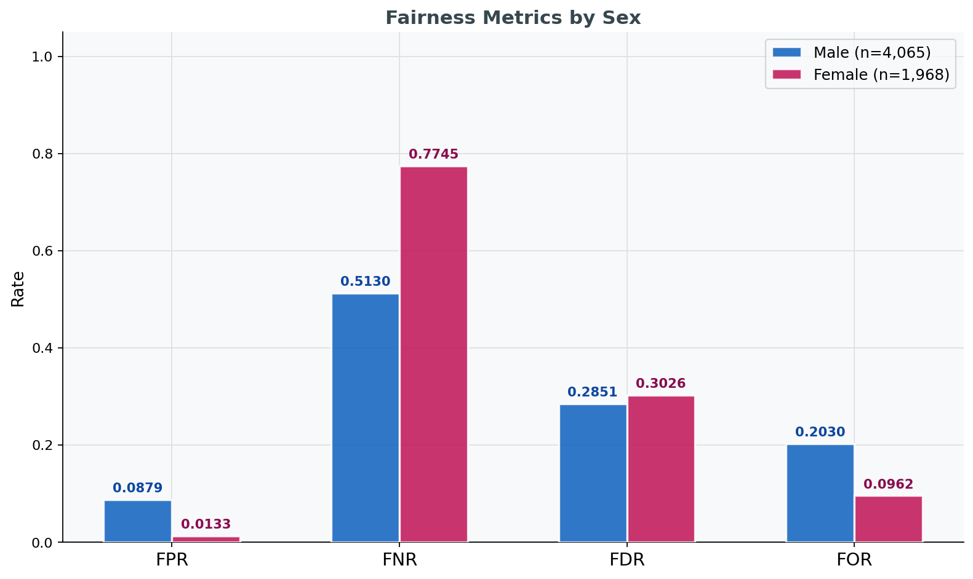
Figure 3: All four fairness metrics by sex.

5.2 Key Finding:- Sex
Women are facing significantly higher False Negative Rate than men. The model predicts low income <=50K for 77.45% of women who actually earn more than $50K, compared to 51.30% for men.

FNR Disparity = 0.7745 - 0.5130= 0.2615

Risk ratio = 0.7745 / 0.5130 = 1.51x

Women have a 1.51 times higher chance of being inaccurately labelled as low income.
The FPR for females (0.0133) is lower than for males (0.0879), indicating that the model is cautious in predicting high income for women, but this results in a significantly higher miss rate.

6. Fairness Analysis: By Race
The test set was split across five racial groups. Confusion matrices and metrics were computed for each group and sorted by group size (largest first).

6.1 Fairness Metrics
Group | n | FPR | FNR | FDR | FOR
White | 5,186 | 0.0655 | 0.5420 | 0.2851 | 0.1722
Black | 559 | 0.0251 | 0.7500 | 0.3750 | 0.1139
Asian-Pac-Islander | 186 | 0.0423 | 0.5227 | 0.2222 | 0.1447
Amer-Indian-Eskimo | 64 | 0.0000 | 0.8333 | 0.0000 | 0.0794
Other | 38 | 0.0286 | 0.6667 | 0.5000 | 0.0556
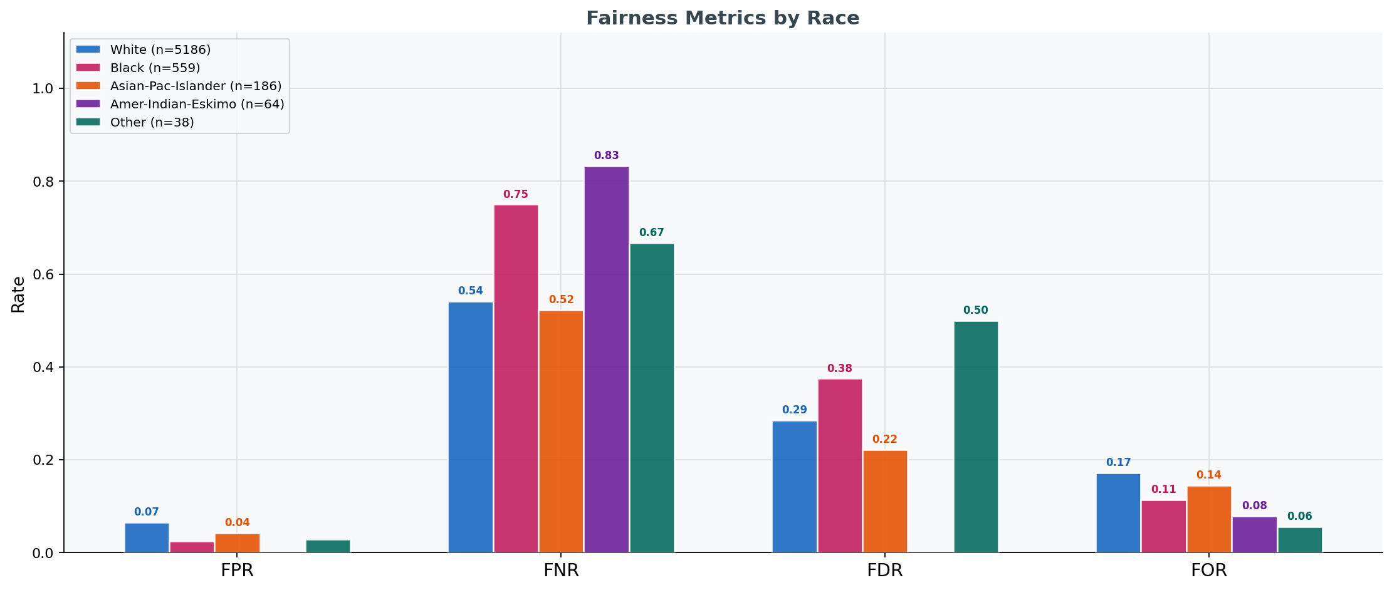
Figure 4: All four fairness metrics by race. FNR is the dominant disparity across all groups.

6.2 Key Findings: Race
Black individuals and Amer-Indian-Eskimo individuals face the highest False Negative Rates. The model is under-predicting high income for these groups.
FNR by Race (wrongly classified as less than 50K despite earning >50K):
White: 0.5420
Black: 0.7500

Asian-Pac-Islander = 0.5227
Amer-Indian-Eskimo: 0.8333 (highest of all groups)
Other:0.6667 (66.67%)

FNR Risk Ratio (Black vs White) = 0.7500 / 0.5420 = 1.38x
FNR Risk Ratio (Amer-Ind vs White) = 0.8333 / 0.5420 = 1.54x
Asian-Pac-Islander individuals are show high FPR (0.0423) compare to Black (0.0251), meaning the model more predicts high income for this group, but this applies to individuals who do not actually earn more than $50K.
Note: Amer-Indian-Eskimo and Other are very small subgroups compared others. Their metric estimates carry high statistical uncertainty.

7. Summary:

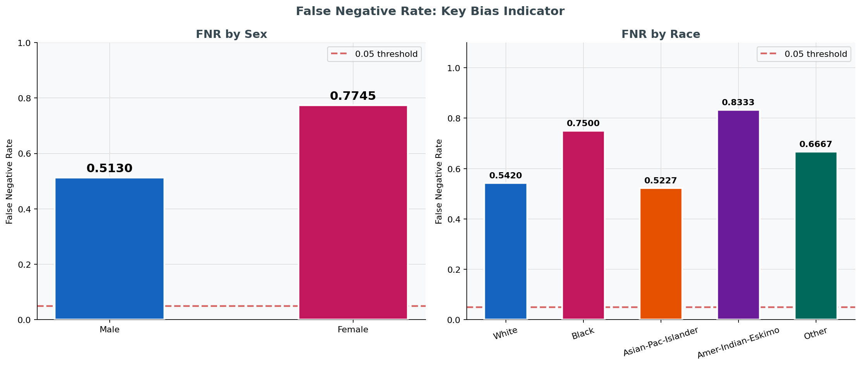
Figure 5: FNR by sex (left) and by race (right).

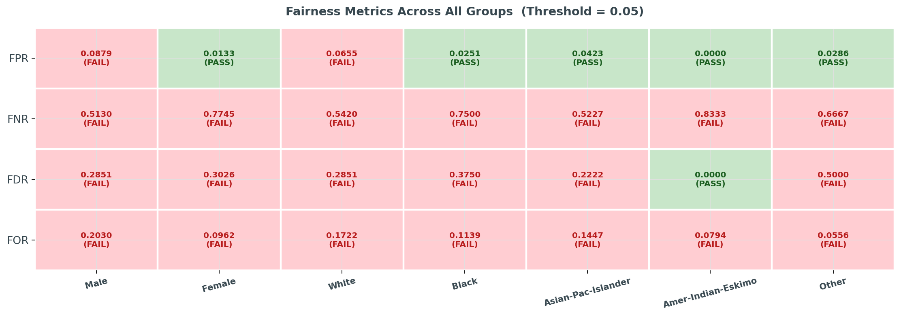
Figure 6: Fairness metrics heatmap across all groups

Dimension | Key Disparity | FNR Value | Status
Sex: Female | Women systematically under-predicted for high income | 0.7745 | FAIL
Sex: Male | Men also under-predicted but less severely | 0.5130 | FAIL
Race: Amer-Ind-Eskimo | Highest FNR of any group; model rarely predicts >50K | 0.8333 | FAIL
Race: Black | Elevated FNR; 75% of high-earning Black individuals missed | 0.7500 | FAIL
Race: Other | Elevated FNR; small sample (n=38) | 0.6667 | FAIL
Race: White | Lowest FNR across race groups but still far above threshold | 0.5420 | FAIL
Race: Asian-Pac-Isl. | Higher FPR relative to other groups; comparable FNR to White | 0.5227 | FAIL

Every group fails the 0.05 fairness threshold on FNR. This is a direct consequence of the model performing poorly overall on the >50K class (Recall = 0.45). The disparity is not that some groups pass while others fail, but that the degree of failure is unequal, with women and Black and Amer-Indian-Eskimo individuals bearing a significantly higher cost.

8. Limitations

- No causality
- Small subgroups
- No mitigation applied
- Single model
- Binary sensitive attributes

